---- TEAM vdx----
Viet Do – doxuanviet1996@kaist.ac.kr – Contribute 50%
Hullas Jindal – jindal@kaist.ac.kr – Contribute 50%
No token used.

Viet Do’s comments: I struggle really hard during the first few days doing the project. The difficulty that I encountered is related to the C language. There are many confusing syntaxes that I has never seen before and take lots of time to figure out (even after I finished the project, there are still places where I do not fully understand). My recommendation for future semester would be to have an additional tutorial explaining briefly about the language.
Example: (void *), pointer and address, thread_func, UNUSED, etc.
Thanks.
ALARM CLOCK
===========

---- DATA STRUCTURES ----
>> A1: Copy here the declaration of each new or changed `struct' or `struct' member, global or static variable, `typedef', or enumeration. Identify the purpose of each in 25 words or less.
static struct list wait_list;
A list containing processes that are in BLOCKED state, which are waiting to be wake up.

struct thread {
…
int64_t wakeup_time;
...
}
Each thread will have a wakeup_time variable, which indicate the time point where it should wake up.

---- ALGORITHMS ----
>> A2: Briefly describe what happens in a call to timer_sleep(), including the effects of the timer interrupt handler.
Calling timer_sleep() now will call to function thread_wait(int ticks) in thread.c, which sleep the current thread until the timer_ticks() reach ticks.
“Sleep” here means adding that thread to the wait_list and then block it.
The timer interrupt handler is called periodically every ticks, which will call to thread_tick(). In function thread_tick(), wake up any thread in the wait_list that has reached it’s wakeup_time by iterating through it.
“Wake up” here means remove that thread from the wait_list and add it to the ready_list.
>> A3: What steps are taken to minimize the amount of time spent in the timer interrupt handler?
We keep the wait_list in sorted order, so when iterate through it to wake up the threads, we stop immediately when can’t stop a thread (the remaining threads have later wakeup_time).

---- SYNCHRONIZATION ----

>> A4: How are race conditions avoided when multiple threads call timer_sleep() simultaneously?
Multiple threads do not share resources when calling timer_sleep(), so no action needs to be made to avoid race condition.
>> A5: How are race conditions avoided when a timer interrupt occurs during a call to timer_sleep()?
Interrupt are turned off before blocking the thread and turned back to old state afterwards.

---- RATIONALE ----

>> A6: Why did you choose this design? In what ways is it superior to another design you considered?
Another design would be to maintain the wait_list in increasing wakeup_time order and when iterating it to wake threads up, immediately stop when unable to wake a thread up. However the complexity of such algorithm is the same, and implementing it is harder, so I choose the former algorithm.
PRIORITY SCHEDULING
===================

---- DATA STRUCTURES ----
>> B1: Copy here the declaration of each new or changed `struct' or `struct' member, global or static variable, `typedef', or enumeration. Identify the purpose of each in 25 words or less.
struct thread
{
…
int true_priority;
struct list_elem donate_elem;
struct list donator;
struct lock *waiting_lock;
...
}
A thread now has a priority and true_priority var, where true_priority shows its initially priority or priority set by thread_set_priority(), and priority is it’s current priority. priority is always greater than or equal to true_priority, because of priority donation.
>> B2: Explain the data structure used to track priority donation. Draw a diagram in a case of nested donation.
A thread has a list called donator, which contains all the threads that are currently donating to it. It also has a list_elem donate_elem to show which thread is it donating to. (That donate_elem will be in the donated thread’s donator list).
*waiting_lock is the lock that this thread is waiting for.
A thread can wait for at most one lock, therefore also donate priority to at most one thread.
Below is a diagram showing briefly a simple case:
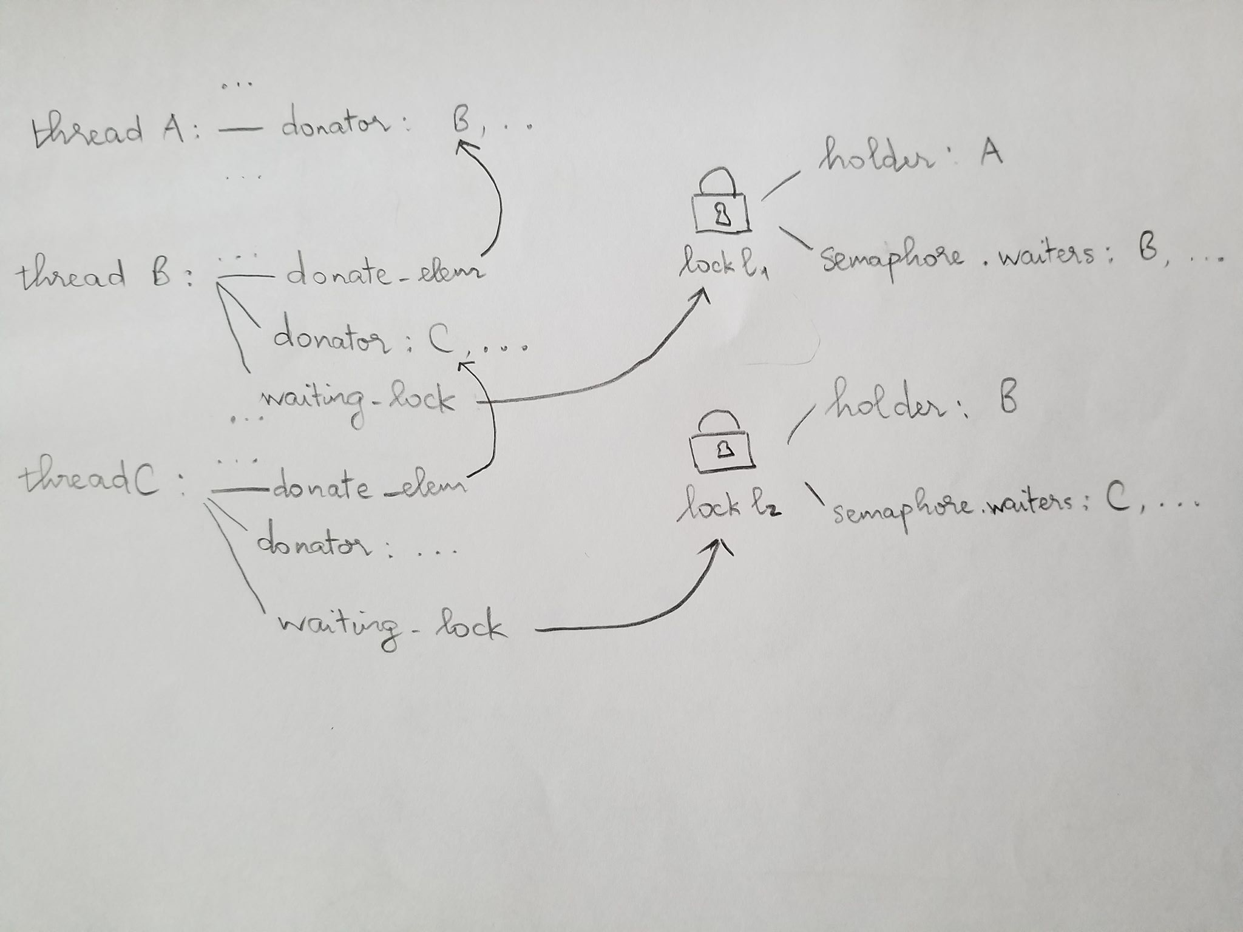
---- ALGORITHMS ----
>> B3: How do you ensure that the highest priority thread waiting for a lock, semaphore, or condition variable wakes up first?
For lock and semaphore, iterate through the semaphore’s waiters and choose the thread with highest priority.
For condition, iterate through the semaphore list signaled by the condition, choose the semaphore with the highest priority to up that semaphore.
Priority of a semaphore is the highest priority among that semaphore’s waiters.
>> B4: Describe the sequence of events when a call to lock_acquire() causes a priority donation. How is nested donation handled?
Inside lock_acquire(), if the lock’s holder is not NULL, then the current thread will donate it’s priority to the lock’s holder. This is done by adding the current thread to the holder’s donator list, and update the holder’s priority by calling update_priority().
update_priority() will update priority of the thread passed to it by choosing the maximum between it’s true_priority and priority of it’s donators.
If update_priority() successfully change the thread’s priority, and that thread is waiting for a lock, then recursively call update_priority() of that waiting_lock’s holder, then recursion again if needed, etc. Recursion will eventually end when donations are made to a thread not waiting for a lock.
The recursive part above is how we deal with nested donation.
>> B5: Describe the sequence of events when lock_release() is called on a lock that a higher-priority thread is waiting for.
When releasing a lock, we remove all the waiters of that lock from the donator list of the current thread, then update_priority() of the current thread. In that way, the current thread’s priority will get it true value, and yield if has lower priority compare to some threads in the ready_list.
---- SYNCHRONIZATION ----
>> B6: Describe a potential race in thread_set_priority() and explain how your implementation avoids it. Can you use a lock to avoid this race?
Recall our implementation of the function:
void thread_set_priority (int new_priority) {
enum intr_level old_level = intr_disable();
thread_current ()->true_priority = new_priority;
update_priority(thread_current());
intr_enable();
if(should_yield()) thread_yield();
}
If we do not disable interrupt, then a potential race would be:
thread_current ()->true_priority = new_priority;
thread_current ()->true_priority = new_priority;
update_priority(thread_current());
update_priority(thread_current());
The function update_priority() is very important and has to activate right after we update the priority because it might update the priority of some threads in the ready_list, and If we interrupt in the middle of the process, then the thread that gets wake up after interruption can be different.
We dont think that using lock is feasible in this situation, the solution would be to disable the interrupt.
---- RATIONALE ----
>> B7: Why did you choose this design? In what ways is it superior to another design you considered?
Our design satisfies two important requirement:
- Return the highest priority threads when waking up from semaphore.
Another way to implement this part is to always keep the waiters list in sorted order, however there are action that changes priority of threads that are already in the waiters list, so we have to modify it anyway. This implementation is more complex compare to our design.
- Take care of priority donation, including nested donation.
We can implement without using the donator, then for every thread we have to hold a lock_holding list instead, and to get the priority of the thread we have to iterate through that list to get the highest one. This implementation is equivalent to our design in complexity and runtime, so both are feasible.
SURVEY QUESTIONS
================

Answering these questions is optional, but it will help us improve the course in future quarters. Feel free to tell us anything you want--these questions are just to spur your thoughts. You may also choose to respond anonymously in the course evaluations at the end of the quarter.

>> In your opinion, was this assignment or any one of the two problems in it, too easy or too hard? Did it take too long or too little time?

>> Did you find that working on a particular part of the assignment gave you greater insight into some aspect of OS design?

>> Is there some particular fact or hint we should give students in future quarters to help them solve the problems? Conversely, did you find any of our guidance to be misleading?

>> Do you have any suggestions for the TAs to more effectively assist students, either for future quarters or the remaining projects?

>> Any other comments?

